Errata (11/22/13) For
Libby/Libby/Short
Financial Accounting, 8e

Text
Page 128
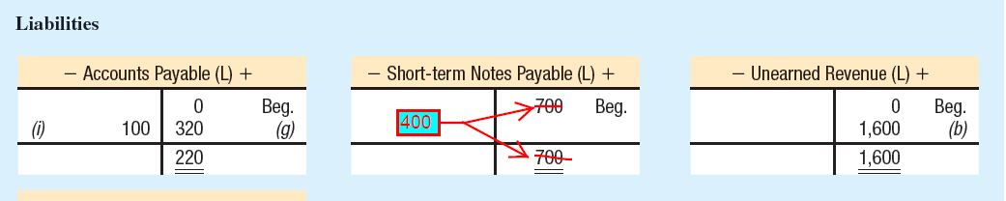

Page 235, Exhibit 5.4
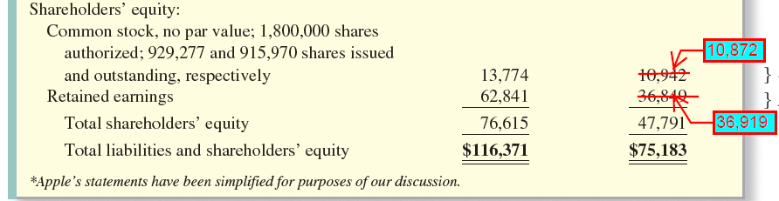

Page 240, Exhibit 5.6
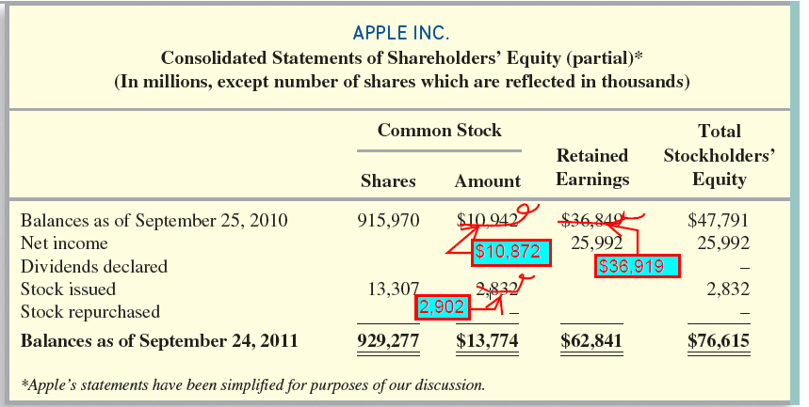

Page 592
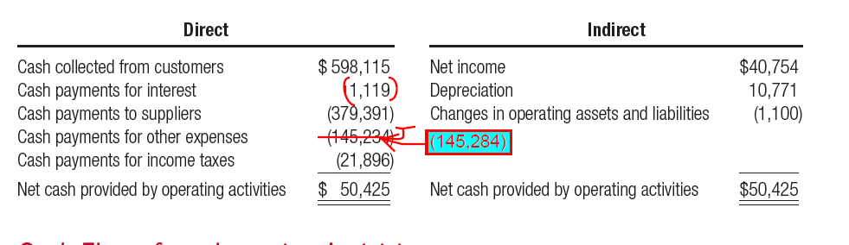

Page 687, CP13-4
Note: Edits do not affect solutions.
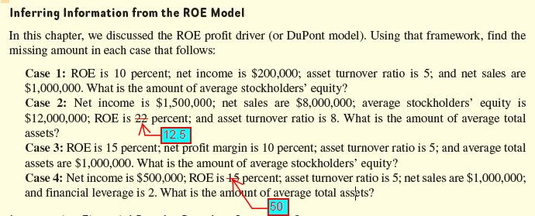

MBA Companion

Page 16, Exhibit S.7:
