INSTRUCTOR NOTES: CHAPTER 5

ACTIVITY-BASED COSTING AND MANAGEMENT

Learning Objectives

1. Compute product costs under a traditional, volume-based product-costing system.

2. Explain how an activity-based costing system operates, including the use of a two-stage procedure for cost assignment, the identification of activity cost pools, and the selection of cost drivers.

3. Explain the concept of cost levels, including unit-level, batch-level, product-sustaining-level, and facility-level costs.

4. Compute product costs under an activity-based costing system.

5. Explain why traditional, volume-based costing systems tend to distort product costs.

6. Explain three criteria for selecting cost drivers.

7. Discuss several key issues in activity-based costing, including data collection and storyboarding.

8. Explain the concepts of activity-based management and two-dimensional ABC.

- Explain and execute a customer-profitability analysis.

10. Understand and discuss how activity-based costing is used in service-industry organizations.

Chapter Overview

I. Traditional, Volume-Based Product-Costing Systems

II. Activity-Based Costing (ABC) Systems
- Stage one: Overhead costs are assigned to activity cost pools.
- Identification of cost pools
1. Unit-level activities
2. Batch-level activities
3. Product-sustaining activities
4. Facility-level activities
B. Stage two: Overhead costs are assigned to products.

III. Activity-Based Costing: Some Key Issues
A. Cost drivers
B. Collecting ABC data
1. Interviews and paper trails
2. Storyboarding
3. Multidisciplinary ABC project teams
C. Activity dictionary and bill of activities

IV. Activity-Based Management (ABM)
A. Two-dimensional ABC
B. Using ABM to identify non-value-added activities and costs
A focus on activities

- Customer Profitability Analysis

- Activity-Based Costing in the Service Industry

KEY CONCEPTS

1. TRADITIONAL, VOLUME-BASED COSTING SYSTEMS

- The manufacturing and service environments have changed as a result of ever-increasing international competition, technological innovation, and advances in computerized systems.

- Many companies still use traditional volume-based (sometimes called throughput-based) costing systems (as described in Chapters 3 and 4). These systems generally group overhead into one cost pool and apply overhead to products based on direct labor, with labor being a measure of volume.

NOTE: A traditional volume-based, product-cost system may function in a satisfactory manner for inventory valuation. The overhead applied via the traditional product-costing system, however, does not bear a close enough relationship to the resources required to build different products or perform different services.

- In the past, accountants felt there was a high correlation between overhead and labor. However, with increasing factory computerization and automation (and the reduction of hands-on labor), this is not always the case today.

- ACTIVITY-BASED COSTING SYSTEMS

- Many organizations are changing to activity-based costing (ABC) systems. This system improves product costing and management decision making, and involves two stages in allocating manufacturing overhead.

- Stage one: The overhead costs of an organization's significant activities are first isolated into cost pools. The cost pools (and related costs) fall into the following broad categories, which collectively are known as a cost hierarchy:

- Unit level—activities that must be done for each unit of production (e.g., machining)

- Batch level—activities that are performed for each batch of product (e.g., setup, quality-assurance, and receiving)

- Product-sustaining level—activities that are performed to support an entire product line (e.g., engineering)

- Facility (or general operations) level—activities that are required for the entire manufacturing process to occur (e.g., plant management, plant maintenance, and depreciation)

  - Stage two: The next step involves identification of a cost driver for each pool. The system then assigns overhead costs by using the cost drivers and assessing the relative proportion of the activity consumed by a product.

    - This process results in the calculation of a pool rate, a per-unit cost of the cost driver, and an eventual cost for each product line.

  - Costing is improved when ABC is used because the system identifies products that were overcosted or undercosted by traditional methods.

    - In many cases, traditional, volume-costing systems overcost high-volume product lines and undercost complex, relatively low-volume lines. Thus, high-volume products essentially subsidize the low-volume lines.

      - ABC uses multiple drivers because more than one item drives the costs of an organization. Not all activities are unit-level in nature, and ABC allows a user to also recognize batch-level, product-sustaining level, and facility-level activities.

      - Costing is more equitable especially in the case of diverse products (and widely varying consumption ratios, which show the proportion of an activity consumed by a given product). No single cost driver can accurately assign overhead when products use activities differently and consume costs in a disproportionate manner.
.

THE DISTINCTIVE FEATURE OF ACTIVITY-BASED COSTING IS THAT IT RECOGNIZES THAT OVERHEAD COSTS ARE CAUSED BY ACTIVITIES AND THAT ACTIVITIES MAY NOT BE CAUSED SOLELY BY VOLUME, BUT BY OTHER TYPES OF ACTIVITIES.

COST DRIVERS FOR THE ACTIVITIES SHOULD REFLECT THE COST INCURRENCE IN THE ACTIVITY, EVEN IF COST IS NOT CAUSED BY VOLUME.

Identifying activities that use resources is the most interesting and challenging part of the ABC process, from which much of the value of activity-based costing comes. A cost-benefit consideration dictates that companies identify only the most important activities.

How A Two-Stage Product Costing System Works.

Let’s assume a manufacturing operation. Direct costs are assigned directly to products or services. The basic approach in product costing is to allocate manufacturing overhead costs in the cost pools that record manufacturing costs and assign, or allocate, these costs to the products or services of interest by using appropriate cost allocation bases or cost drivers.

The two-stage approach in allocating manufacturing overhead in product costing involves the following:

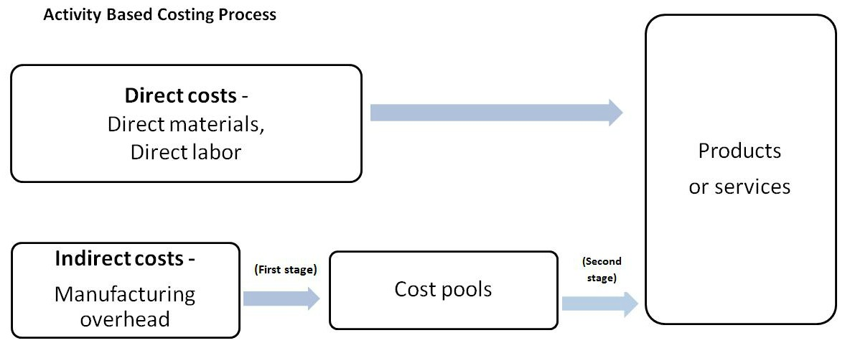

- The first-stage cost objects (cost pools) are the overhead accounts (e.g., machine-related costs and direct labor-related costs) captured by the cost accounting system.

- The two-stage approach separates plant, or manufacturing, overhead into two or more cost pools based on the account in which the costs were recorded.

- The allocation in the first stage permits selection of multiple cost drivers that were used to allocate costs to products.

- Another common choice for first-stage cost objects is to use departments or lines within the plant.

- The allocation of overhead costs to departments is not as simple as it is when overhead accounts are used because the costs are not necessarily recorded at the department level.

- In the second stage, cost pool costs are assigned to objects.

Complexity and special handling required during production may distort the product costs reported when the traditional costing method is used. The two-stage system, on the other hand, allows the firm to develop product costing systems that more closely align the allocation of costs with the use of resources.

- The distinctive feature of activity-based costing is that it recognizes that overhead costs are caused by activities and that activities may not be caused solely by volume, but by other types of activities. Cost drivers for the activities should reflect the cost incurrence in the activity, even if cost is not caused by volume. Determining the cost driver is an important, key decision, and the quality of the process depends upon this decision.

- A Cost Hierarchy represents a classification of cost drivers into general levels of activity, volume, batch, product, etc. Four possible levels of cost hierarchy include
  - volume-related,
  - batch-related,
  - product-related, and
  - facility-related.
- Cost drivers may also be classified as being:
  - Structural cost drivers
  - Organizational cost drivers
  - Activity cost drivers
- Conceptually, the denominator in the ratio of cost per unit of activity should be the Practical Capacity of the facility. Practical capacity represents the maximum possible capacity, allowing for normal repairs and maintenance.

See Exhibit 5-3 for a visual of the process.

3. ACTIVITY-BASED COSTING: SOME KEY ISSUES

- A cost driver is a characteristic of an event or activity that results in the incurrence of costs. Three factors are important when selecting the most appropriate costs driver: the degree of correlation, cost of measurement, and behavioral effects.

  - The degree of correlation between activity consumption and consumption of the driver

NOTE: For a service business, for example a dialysis clinic, the number of dialysis treatments should be an appropriate cost driver to trace the operating costs of dialysis machines. Nursing administration cost can be applied by using the number of treatments as its cost driver. Finally, square footage, estimated kilowatt usage, and number of patients are cost drivers that could be chosen for assigning a hospital’s facility-level costs.

- Cost assignment accuracy is increased when the number of activity cost pools is increased. However, that requires more cost drivers, which will result in higher costs.

- Behavioral effects must be considered in the selection of cost drivers.

- An example of behavioral impact may be the choice of the number of material moves to allocate material-handling cost. Selection of such a base may induce managers to reduce the number of times materials are moved, thus reducing total material-handling costs.

- Collecting ABC data is necessary to analyze documents in order to assign costs of activities to product lines on the basis of the amount of activity generated by each product.

- Interviews and paper trails are often used.

- Many firms prepare a process flow chart that shows the activities and relationships among activities. This procedure, called storyboarding, is needed to organize the data in an ABC project.

- A typical ABC project involves multidisciplinary teams, with personnel selected from various functional areas.

- Many companies compile a complete listing of all activities identified and used in an ABC analysis (called an activity dictionary). Similarly, many firms create a bill of activities, which is a complete listing of the activities associated with a particular product or service.

4. ACTIVITY-BASED MANAGEMENT (ABM)

- Activity-based management (ABM) refers to the use of activity-based costing information to support organizational strategy, improve operations, and manage costs.

- An ABC system assigns resource cost to a company's cost objects (i.e., the cost assignment viewpoint). With a process viewpoint, the emphasis now is on the activities themselves—what causes them, the events that trigger them, and the related linkages.

- A goal of ABM is to identify and eliminate non-value-added activities: activities that are either unnecessary and dispensable, or necessary but inefficient and improvable.

- Common examples of non-value-added activities include move, wait, and storage time.

- These activities give rise to non-value-added costs, or costs that can be eliminated without deterioration of product quality, performance, or perceived value.

NOTE: Airlines provide a classic example that illustrate non-value-added costs. When carriers began selling tickets on-line through their Web sites, the firms were able to reduce, or in some cases eliminate, the need for travel agents to provide flight information and sell tickets (i.e., an activity).

- CUSTOMER PROFITABILITY ANALYSIS

- Customer profitability analysis uses activity-based costing to determine the activities, costs, and profit associated with serving particular customers.

- Factors that influence customer profitability include order quantity, order frequency, special packaging and/or delivery needs, engineering design changes, sales visits/contacts, and, in general, customized services.

- Customers can often be educated in terms of buying habits, with the result being lower overall costs for both the purchaser and the seller.

- Appropriate tools of analysis include bar graphs, costs expressed as a percentage of gross margin, and trend analyses.

- ACTIVITY-BASED COSTING IN SERVICE ORGANIZATIONS

- The overall objectives of ABC in service firms are identical to those for manufacturing organizations.

- The general approach of identifying activities, cost pools, and cost drivers is the same for service and manufacturing entities as well.

