Chapter 5 (Activity-Based Costing) Video

This video builds upon the text, PowerPoint slides, and instructor notes. Please read them before watching the video.

Many companies still use traditional volume-based (sometimes called throughput-based) costing systems (as described in Chapters 3 and 4).
- These systems generally group overhead into one cost pool and apply overhead to products based on direct labor, with labor being a measure of volume.

In the past, accountants felt there was a high correlation between overhead and labor.

However, with increasing factory computerization and automation (and the reduction of labor as part of the manufacturing process), this correlation is no longer appropriate.

ACTIVITY-BASED COSTING SYSTEMS

Many organizations are changing to activity-based costing (ABC) systems,

ABC recognizes that multiple activities may cause costs to be incurred.

ABC involves two stages:

- STAGE ONE: The costs of an organization's significant activities are first isolated into cost pools, which fall into the following broad categories, and which collectively are known as a cost hierarchy:

- Unit level—activities that must be done for each unit of production (e.g., machining)

- Batch level—activities that are performed for each batch of product (e.g., setup, quality-assurance, and receiving)

- Product-sustaining level—activities that are performed to support an entire product line (e.g., engineering)

- Facility (or general operations) level—activities that are required for the entire manufacturing process to occur (e.g., plant management, plant maintenance, and depreciation)

STAGE TWO: The next step involves identification of a cost driver for each pool.
- The system then assigns overhead costs by using the cost drivers and assessing the relative proportion of the activity consumed by a product.

- This process results in the calculation of a pool rate, a per-unit cost of the cost driver, and an eventual cost for each product line.

The distinctive feature of activity-based costing is that it recognizes that overhead costs are caused by activities.

Cost drivers for the activities should reflect the cost incurrence in the activity, even if cost is not caused by volume.

Identifying activities that use resources is the most interesting and challenging part of the ABC process, from which much of the value of activity-based costing comes.

A cost-benefit consideration dictates that companies identify only the most important activities.

How A Two-Stage Product Costing System Works.

Let’s assume a manufacturing operation.

The basic approach in product costing is to allocate costs in the cost pools that record manufacturing costs and assign, or allocate, these costs to the products or services of interest by using appropriate cost allocation bases or cost drivers.

The two-stage approach in allocating manufacturing overhead in product costing involves the following:

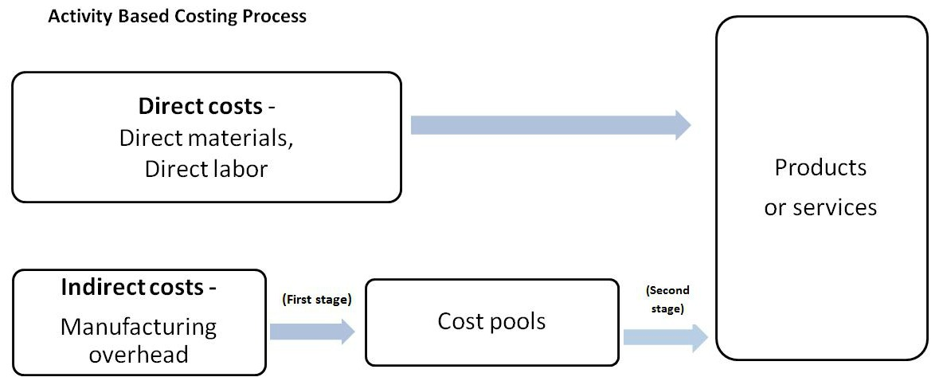

ABC PROCESS

Activity-based costing (ABC) is a two-stage product costing method:
(1) assigns costs to cost pools (usually based upon activities) and
(2) allocates them to products based on the products’ consumption of activities.

- The cost pools in the two-stage approach now accumulate activity-related costs.

- An activity is any discrete task that an organization undertakes to make or deliver a product or service.

- Activity-based costing is based on the concept that products consume activities and activities consume resources.

- Activity-based costing involves the following four steps:
  - Identify the activities that consume resources and assign costs to them.
  - Identify the cost driver(s) associated with each activity.
    - A cost driver is any factor that causes, or “drives,” an activity’s costs.
    - Determining the cost driver is an important, key decision, and the quality of the process depends upon this decision.
  - Compute a cost rate per cost driver unit or transaction. Each activity could have multiple cost drivers.
  - Assign costs to products by multiplying the cost driver rate by the volume of cost driver units consumed by the product.
    - Costs are usually applied on the basis of predetermined overhead rates
    - Therefore, at the end of each period, an amount of overhead will be over (under) applied for each cost pool.

Advantage of ABC

Costing is improved when ABC is used, as the system identifies products that were overcosted or undercosted by traditional methods.
- In many cases, traditional, volume-costing systems overcost high-volume product lines and undercost complex, relatively low-volume lines.
- Thus, high-volume products essentially subsidize the low-volume lines.

COST DRIVERS

The degree of correlation between activity consumption and consumption of the driver has a significant impact on the accuracy of the ABC-costing effort.

Cost drivers are selected based on three criteria:
- Causal relation. Ideally, choose a cost driver that causes the cost. BEST
- Benefits received. Choose a cost driver to assign costs in proportion to benefits received.
- Reasonableness or fairness. When the first two criteria fail, assign costs on the basis of fairness or reasonableness.

Example (Problem 5-48 from Textbook, partial and modified)

Wilmington Office Equipment Corporation manufactures two types of filing cabinets, Deluxe and Executive, and applies manufacturing overhead to all units at the rate of $80 per machine hour. Production information follows:

 | Deluxe | Executive
Direct material cost | $40 | $65
Direct labor cost | $25 | $25
Budgeted volume (in units) | 16,000 | 30,000

The controller has determined that the firm’s overhead can be identified with three activities. The data for the three activities are as follows.

 | Manufacturing Overhead | Deluxe | Executive | Total
Number of setups | $1,344,000 | 100 | 60 | 160
Number of machine hours | $3,696,000 | 23,000 | 45,000 | 77,000
Number of outgoing shipments | $1,120,000 | 200 | 150 | 350
Total | $6,160,000

- Compute the overhead allocation to deluxe and executive using the traditional machine hour overhead allocation process.
- Compute the overhead allocation to deluxe and executive using ABC.

Answer.

- Compute the overhead allocation to deluxe and executive using the traditional machine hour overhead allocation process.

$6,160,000 / 77,000 machine hours = $80 per hour
Deluxe: 32,000 hours x $80 = $2,560,000
Executive: 45,000 hours x $80 = $3,600,000
Check: $2,560,000 + $3,600,000 = $6,160,000

- Compute the overhead allocation to deluxe and executive using Activity-Based-Costing (ABC).

 | Manufacturing Overhead | Deluxe | Executive | Total
Number of setups | $1,344,000 | 100 | 60 | 160
Cost per setup: $1,344,000 / 160 = $8,400 |  | $840,000 | $504,000 | $1,344,000
Number of machine hours | $3,696,000 | 32,000 | 45,000 | 77,000
Cost per machine hour: $3,696,000 / 77,000 = $48 |  | $1,536,000 | $2,160,000 | $3,696,000
Number of outgoing shipments | $1,120,000 | 200 | 150 | 350
Cost per number of shipments: $1,120,000 / 350 = $3,200 |  | $640,000 | $480,000 | $1,120,000
Total Allocated Overhead Costs | $6,160,000 | $3,016,000 | $3,144,000 | $$6,160,000

