C521 ORGANIZATION

The course is organized in Canvas Around Modules

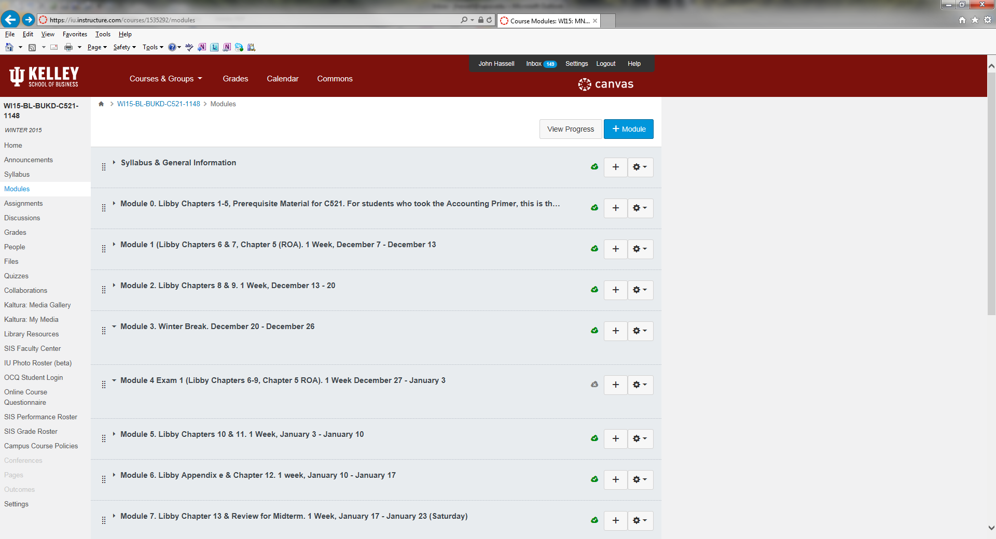

SYLLABUS & GENERAL INFORMATION MODULE contains syllabus and other information.
Please Read the Documents in the Module

MODULE 0 contains prerequisite information
- Students who took the KD accounting primer will have completed this material

MODULE 1 contains the first week’s assignment, Chapters 6 & 7
- Normally we cover two chapters per week
- Each chapter contains
  - Instructor Notes
  - Text PowerPoint Slides
  - Chapter Instructor Video
  - Answers to end of chapter assigned homework exercises and problems (see syllabus)
  - Chapter Ungraded Practice Quiz
  - Graded Problem
  - Graded Quiz

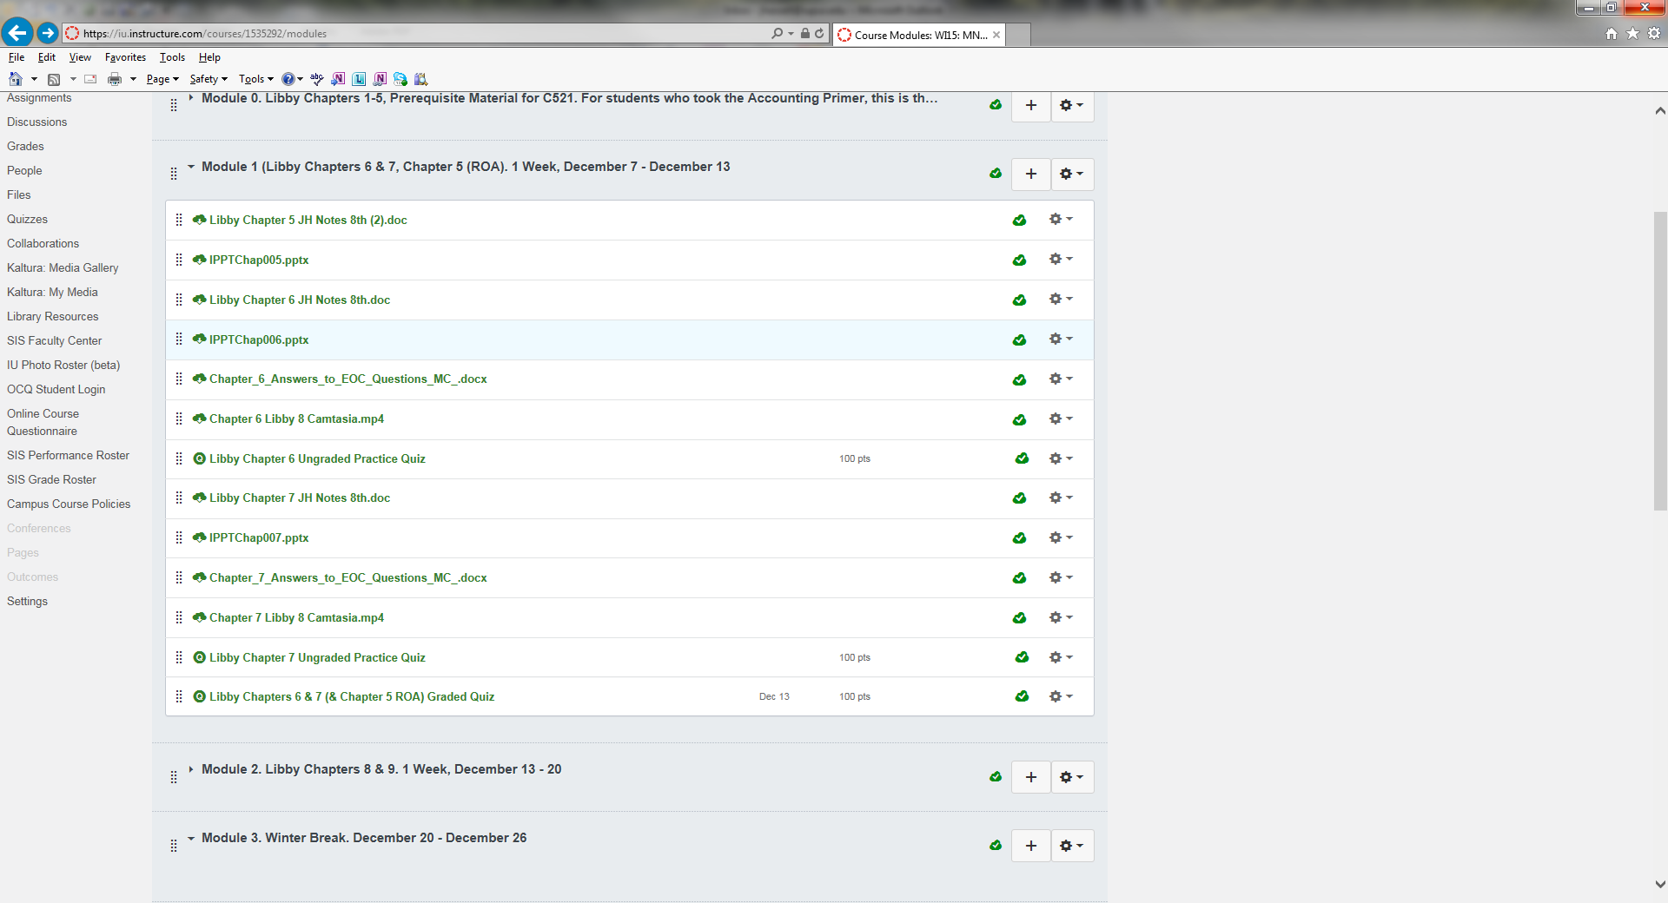

MODULE 2 Covers Chapters 8 & 9

MODULE 3 is Winter Break

MODULE 4 IS EXAM 1 (Libby chapters 6-9, Chapter 5, ROA)
- An exam is scheduled early so that students can have feedback on their progress
- Exam 1 is 25% of the course grade

