Performance Management

Establishing Performance Expectations

Performance Management is a framework for conversations between supervisor and employee throughout the year.

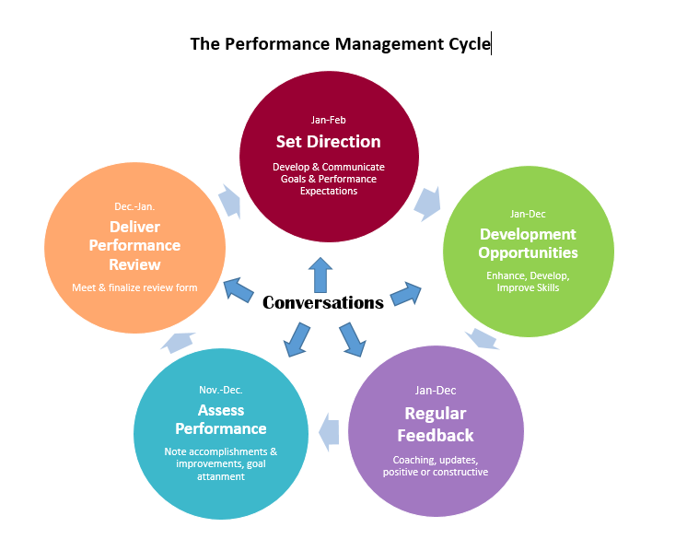

Create the Right Environment

Creating an environment for high quality performance discussions starts well before you decide to provide feedback. The following is a list of tips to create a productive environment and to foster high quality performance discussions.
- Build positive, trusting working relationships by showing that you care about staff member’s interests, development and wellbeing
- Communicate openly – share information that helps others do their jobs and engage others when making decisions that affect them
- Encourage feedback – ask for feedback and give it regularly
- Role model an openness to feedback – accept feedback graciously
- Act on feedback – even if you don’t agree with the feedback you may need to work on changing the other person’s perception
- Work on the principle of “no surprises” – let everyone you supervise and manage know how they are doing on a regular basis as part of the way you work

Planning for Performance

Development of a performance plan happens at the beginning of the performance cycle or on commencement in a new role. An effective and meaningful performance planning discussion should lead to a shared and agreed understanding between a manager/supervisor and the staff member or team about:
- What needs to be done and achieved (main tasks, projects or deliverables)
- How work will be done (what conduct and behavior the staff member or team will use or develop while they are at work, i.e., collaboration)
- What support is required (skills and knowledge that need to be developed further and how these will be addressed so that the staff member can achieve the agreed upon goals)
- What good performance looks like (specific things we will see when it’s all going well, i.e., consulting fully with colleagues and experts when writing a policy, an important deadline met, fewer customer/service user complaints on avoidable matters)
- Clarity on how and when further discussion about performance will happen

Key Elements in the Planning Process:
- Understand the mission of IUSM and your unit
- Understand the values and goals of IUSM and your unit
- Link individual expectations to IUSM mission, values and goals

Performance Expectations

What is a performance expectation?
- Describes the results expected for the fully satisfied performance of a job function/task
- Defines “how well” each function or task must be performed
- Identifies competencies significant to the accomplishment of performance goals
- Reinforces the notion that accomplishment at any cost is not acceptable – must be within the framework of acceptable and desired work traits
- Provides a benchmark against which to evaluate work performance

A performance expectation should be:
- Derived from mission, goals and values
- Mutually understood
- Developed collaboratively, if appropriate
- Descriptive of how a job is to be performed
- Descriptive of fully satisfactory performance
- Expressed in measurable/observable terms
- Reasonable and attainable

Establishing Performance Expectations

Step 1 | Ensure the position description is current and accurately reflects the responsibilities of the position
Step 2 | Identify the essential functions or critical responsibilities of the position – the reason the position exists; typical number is 5-8
Step 3 | Identify the key tasks for each critical responsibility and how each task is accomplished
Step 4 | Define exceeds vs. meets vs. does not meet expectations for performance standards  Consider whether tasks are new or routine or whether collaboration with others is necessary to accomplish
Step 5 | Recognize and address what barriers may exist that will impact performance

Double check performance expectations:
- Are they clear? Does the employee know what an acceptable level of performance looks like?
- Are they quantifiable, observable, verifiable?
- Are they attainable, reasonable?
- Are they challenging? Does the employee need to exert a reasonable amount of effort to reach a fully successful performance level?
- Are they fair? Are the comparable to those for other employees in similar positions but also reflect any uniqueness to the position? Do they allow for some margin of error? Do they reflect tenure and experience in the position?
Performance
External to Performer
(80% of Performance Issues)
Environmental  (Intangibles) |  | Resources  (Tangibles)
Organizational Systems & Processes | Incentives | Cognitive Support |  | Tools | Physical Environment
- Clear goals  - Job design  - Clear processes and policies  - Authority  - Appropriate workload  - Access to right people | - Compensation  - Feedback  - Coaching  - Positive reinforcement  - Interesting meaningful work | - Job aids  - Documentation  - Work flow diagrams and charts  - Cheat sheets |  | - Computers and other electronic equipment  - Software  - Video/DVD  - Calculators  - Automobiles  - Telecommunication devices | - Noise  - Light  - Temperature  - Physical layout
Internal to Performer
(20% of Performance Issues)
Skills/Knowledge |  |  | Inherent Ability
- Training and professional and career development  - On-the-job training  - Feedback and coaching  - Self-study |  |  | - Intelligence  - Emotional maturity  - Physical attributes  - Education  - Artistic gifts  - Internal motivation  Creativity and innovation
Human Performance Model

Source: Adapted from Wile, David, “Why Doers Do”; P&I Journal, Volume 35, #2, pp. 30-35, February 1996
Steps to the Performance Planning Conversation
- The most important part of this process is the discussion between manager/supervisor and staff member.
- The focus should be on taking the time to have a meaningful and effective discussion.
The most effective performance planning discussions are “two-way”—exchanging views, asking questions and developing a shared and agreed understanding.
Step 1: Prepare for the Performance Planning Conversation
Manager/Supervisor | Staff Member
- Review school and unit goals and priorities  - Determine job-specific and leadership (if applicable) competencies | - Review your job description and last performance review  - Think about your work and personal development objectives  - What do you enjoy about your job? What do you like least or find more challenging about your job?  - What are your career goals? What do you need to do to work towards these goals (e.g., professional development, other work experience) and how can your manager support you?  - How do you prefer to be managed and receive feedback?  - Think about procedures or process improvements that would make your work more efficient and effective  - Create a list of recurring tasks, major projects and milestones  - Think, and be prepared to ask any questions you may have, about how your work is connected to the unit or School’s strategic priorities, goals, and objectives
Step 2: Discuss outputs, projects, and deliverables
- What elements of the unit’s strategic priorities, goals, and objectives will the employee be responsible for?  - Where do you think we need to focus our energies this year? | - What are your objectives, responsibilities and key activities for the year ahead?  - What elements of your work are you going to focus on improving this year?
Step 3: Develop SMART goals
- See SMART Goals Handout and/or Worksheet
Step 4: Discuss development goals
- What skills and/or knowledge does the employee need to acquire or enhance in order to do a good job?  - Jointly establish goals to meet development priorities. Development opportunities can be formal (workshops, training) or informal (coaching, self-study, challenging assignments).  - Discuss development opportunities necessary for advancement. | - What skills and knowledge will be important to your role this year?  - What skills and knowledge do you need to focus on developing this year in order to do a good job?  - What learning and development activities will you undertake this year?  - How will new skills and knowledge be shared with others?  - How will your new skills and knowledge be applied on the job?  - What skills or experience do you need to develop to advance in your career?
Step 5: Discuss barriers
- What barriers might impede your success in accomplishing your goals?  - What do you base your concern on?  - What are your thoughts on how to manage this concern | - Consider what challenges or obstacles you might encounter in accomplishing your goals  - Be accountable for solutions or alternatives wherever possible
Step 7: Discuss support required
- What would sufficient support look like?  - How regularly do we need to meet to discuss progress?  - What might be a contingency plan if your request for ___ cannot be met?  - What can I do to help you succeed? | - What support do you feel you will need to achieve successfully the objectives?  - What challenges might you experience that your manager may need to be aware of, or assist you with?  - What resources/support do you need to get the job done (other than learning and development activities addressed earlier)?  - Are there any changes to the work environment or arrangements that would assist you to do your job?  - How can your manager assist you to do a good job and possible perform even better?
- Step 8: Following the discussion
- Confirm what has been agreed including any actions such as who will do what and by when
- Decide what will be recorded and how it will be recorded
- Implement what has been agreed including any follow-up actions
- Continue to have performance discussions on a regular basis

