Microsoft Word for Windows: A Guide to Creating Accessible Documents

Microsoft Word for Windows: Adding Alternative Text to Images
- Right-click on image

- Select Format Picture > Layout & Properties

- Select Alt Text
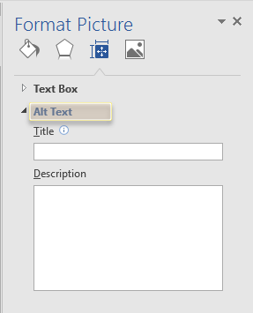
- Type in a description
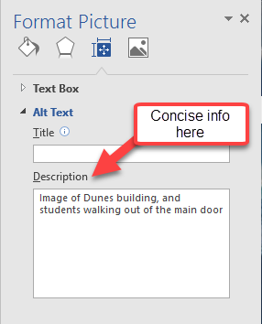

Microsoft Word for Windows: Add Alternative Text to SmartArt graphics

- Right-click a SmartArt graphic

- Select Format Object > Shape Options > Layout & Properties

- Select Alt Text
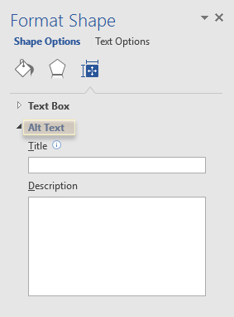
- Type a description
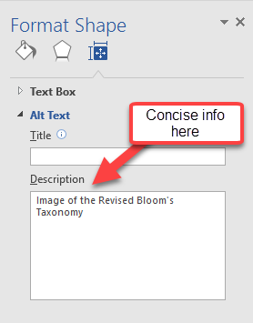

Microsoft Word for Windows: Add Alternative Text to Shapes

- Add alt text to shapes, including shapes within a SmartArt graphic

- Right-click a shape, and then select Format Shape

- In the right pane, select Layout & Properties, and then select Alt Text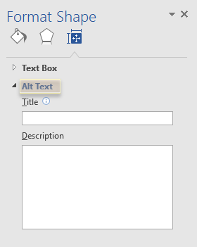
- Type a description
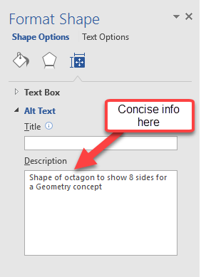

Microsoft Word for Windows: Add Alternative Text to Charts

- Right-click a chart.

- Select Format Chart Area > Chart Options > Layout & Properties

- Select Alt Text
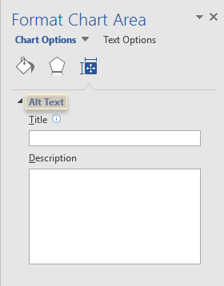
- Type a description
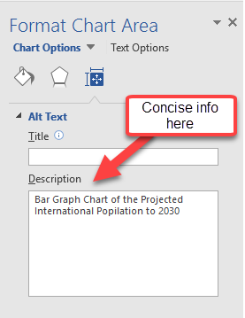

Microsoft Word for Windows: Add Alternative Text to Tables

- Right-click a table

- Select Table Properties

- Select the Alt Text tab

- Type a description
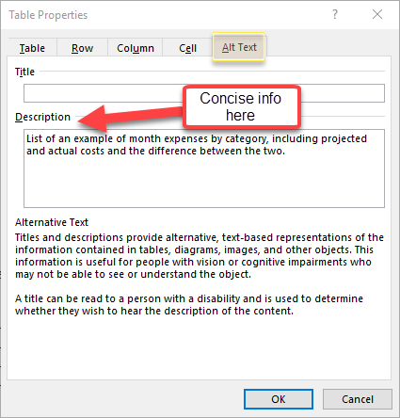

Microsoft Word for Windows: Adding Hyperlink Text and ScreenTips

- Select the text to which you want to add the hyperlink, and then right-click

- Select Hyperlink

- Change the hyperlink text – the hyperlink text should be descriptive in nature

- In the Address box, entire the website address for the hyperlink

Example of Hyperlink Text and Address
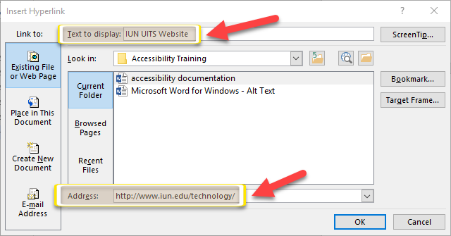

Microsoft Word for Windows: Applying and Verifying Built-In Heading Styles

Using “Heading Styles” in Microsoft Word allows you to not only create accessible documents, but creates an outline that is easy for screen readers to follow the document easily.

- Select the heading text

- On the Home tab, in the Styles group, select a heading style
  - Using Heading 1 for the main heading and Heading 2 – Heading 6 for subheadings. Additional organization and division of topics should use the appropriate heading style without going past Heading 6.

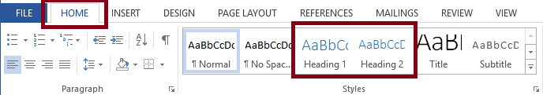

To Verify a Heading Style:

- To verify the heading style, click on View

- Click Navigation Pane and check mark the box to view the headings and the outline of your document
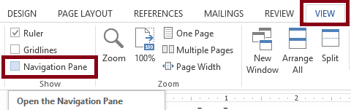

Microsoft Word for Windows: Structuring Data Tables

Using a table structure may be an essential part of your Word document and ensuring the appropriate headers helps as many users as possible to understand and navigate tables and your content. Word does not support row heads but creating accessible column headings does.

- Select the first row

- Go to Table Tools’ Layout tab on the ribbon

- Choose the Repeat Header Rows option in the Data group
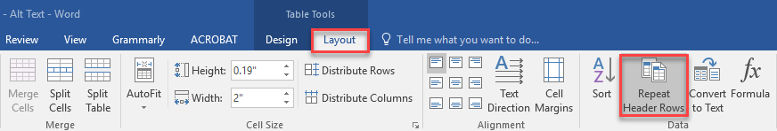

Microsoft Word for Windows: Using Mathematical Context

Microsoft Word documents that contain math equations using the MathType Equation Editor can be converted into other formats while retaining the accessibility functionality of the mathematical content. At this time, Microsoft Word documents must be saved as DOCX and use the MathType Equation Editor to input the math equations.

Those departments that use math equations for their class content will need Math Equator Editor to create content that is compliant with accessibility standards.

Key Points to Address with the MathType Equation Editor

- You will need to install the MathType Equation Editor from Design Science to support accessible math equations in MS Word documents. MathType is available for both the Mac and Windows platform.
- With MathType installed, you can enter equations using the MathType Equation Editor or by adding LaTeX. If using LaTeX, you will need to convert all equations to MathType equations.
- MathType should be used for equations and not for entering text information. Avoid using MathType for formatting purposes.
- At this time, documents must be saved as DOCX in order to be converted into alternate formats using SCRIBE (e.g., DAISY+Math, ePub 3, etc.).
- We are investigating additional input formats, including LaTeX and MathML, to support conversions into alternate document formats. Thank you for your patience.

Microsoft Word for Windows: Adding and Changing Hyperlinks

Microsoft Word automatically creates a hyperlink when a user cuts and pasted a full URL onto a page. Often times, this may not make sense to screen reader users, so more detailed information is needed. Follow the steps below to change the hyperlink.

- Select the text you want linked, right click, and select Hyperlink

- Make sure the Text to Display field is a meaningful description and type in the link URL into the Address bar
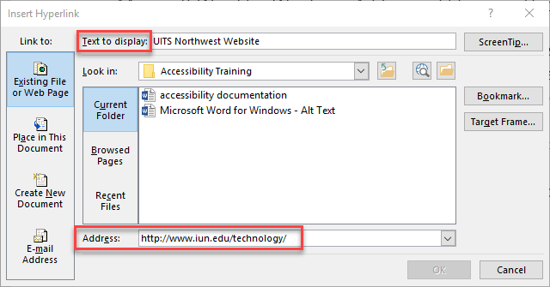

Microsoft Word for Windows: Using the Accessibility Checker

Word has a built in accessibility checker that can identify the most common accessibility issues. You will see accessibility errors, warnings, and tips on how to fix the errors. To start the Office Accessibility Checker in Word, follow the steps below:

- Go to the File tab on the ribbon

- Select the Check for Issues button on from the Info menu

- Choose the Check Accessibility option
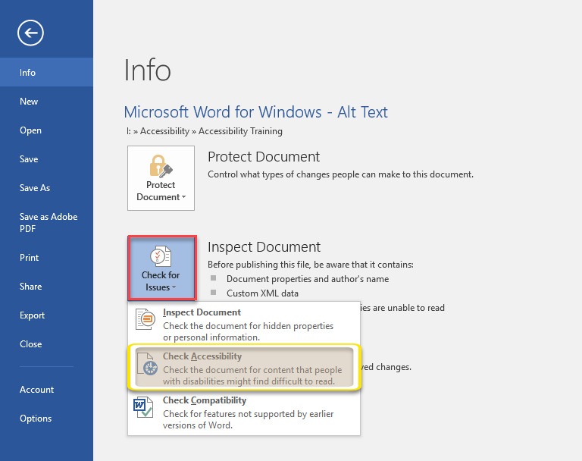

Microsoft Word for Windows: Using Color to Convey Meaning

Color often alone cannot convey the meaning, and especially if someone is color-blind or using assistive technology because the screen reader, does not know color. Ensuring that the text displays well is essential.

- Select your text and then select Home

- Go to font color and select Automatic
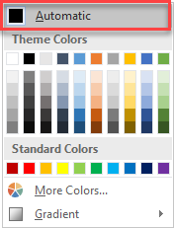
If color is necessary, make sure you use a Color Contrast Analyzer, a free app that lets you analyze colors and contrast. It displays the results immediately.

Consider also adding shapes if you need to indicate a status of some sort, a checkmark symbol in green can be used to indicate, “Pass” and an uppercase X in red, can indicate, and “Fail”. You may want to use an asterisk (*) to show importance in a course as well.

