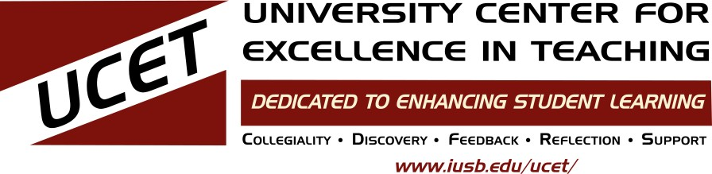
Fall

2022

 | SoTL Institute  Join Sharon Jones and Carolyn Schult for the SoTL Institute, which provides structure and support as you design and carry out your own Scholarship of Teaching and Learning project. Your final product for the Institute will be a proposal for the next Midwest SoTL Conference on March 31, 2023.  Meet Aug 16, 10am-noon in NS 245.  Email UCET@iusb.edu to register! See the flyer for the schedule and information  (20 FDU through Learn and Earn for complete Institute) | PTR Prep group  October-April, UCET PTR Mentors  Work with mentors on your promotion materials. For those turning in a promotion dossier for Senior Lecturer, Teaching Professor, Associate Professor, or Professor in clinical or tenure lines in August 2023.  Contact David Blouin  dblouin@iusb.edu for more information. | Tech Showcase (Sept. 23, morning)  Amy Pawlosky and Joel Langston  Faculty share how they innovatively use  technology in their courses. Join your  colleagues to investigate how YOU can  incorporate new tech into your teaching.
Ungrading workshop “Why Rating Students Undermines Learning (and What to Do Instead).”

Learn from your colleagues about the

Philosophy of Ungrading. The idea is to

focus on learning, rather than sorting or

judging. Rigorous research, as well as

personal anecdotes, provide suggestions

about how a curious faculty member

might shift their pedagogy to better meet

student needs. Led by members of IU

South Bend’s Ungrading Collective. Day

and time to be determined.

 | Teaching for Student Success Modules  Join your colleagues in working through the Teaching for Student Success modules together. Meetings will be on Zoom.  Foundational Modules with Jeff Luppes  Includes Course Design, Assessment, Science of Learning, and Creating Positive First Impressions  Contact UCET to sign up UCET@iusb.edu (1 FDU each session through Learn & Earn, 20 FDU for complete Institute)  Distracted Book Group  Join Jay VanderVeen and Tammy Fong- Morgan to discuss Distracted: Why Students Can't Focus and What You Can Do About It. Keeping students focused can be difficult -- which is why a renowned educator created a scientific solution to one of every teacher's biggest problems.  Radical Hope Book Group  “It has never been more difficult to teach in higher education than in our current moment,” writes Gannon. Yet, he still finds the practice of education to be emancipatory and hopeful. Join Anna Michelle Martinez-Montavon and Jay VanderVeen to discuss this manifesto for our times.  Contact UCET to sign up UCET@iusb.edu  (5 FDU through Learn & Earn) | Online Teaching Strategies  Anna Michelle Martinez-Montavon  Community-building in online courses  With Stacie Merken  Learn about a range of techniques and resources that can help you build an inclusive and inviting learning community in your online course.  Sept. 2, 11am-12:15pm on Zoom  Web Accessibility 101  Simple, proactive techniques to make your digital materials more accessible and usable for everyone.  Sept. 7, Zoom, and Sept. 30, NS 245  Facilitating equitable discussions on Zoom  Zoom settings and facilitation techniques for a less-awkward discussion.  Date: TBD  Email Anna (ama9@iu.edu) for more information
Quality Matters Info Session
Anna Michelle Martinez-Montavon

Learn how you can improve your online
course design using Quality Matters. Learn
about UCET funding for completing
different tiers of the program.
(1 FDUs through Learn & Earn)

(1 FDUs through Learn & Earn)
UCET to YOU
UCET staff
We will do a workshop for your unit, at your place or ours. Topics such as Rubrics, SoTL 101, Canvas, Mindset, Documenting Teaching, Curriculum planning, or your choice!

And always . . .
Workshops on teaching, educational
technology, and careers
Consultations with staff
Teaching/Learning Partners
Video and audio services from Media Services
Peer Review of Teaching training
Mentor-matching
Teaching with Technology grants for teaching tech purchases
MALT grants for Active Learning
FACET/UCET Travel Grants
Great resources on the UCET website through “Resources” and “UCET One- Stop Resources”
PlayPosit Workshop
Amy Pawlosky, Date TBD

Join us for this workshop to find out how PlayPosit can help your students engage more with your video content. Amy will walk you through some of the basic functions of the tool and show you how you can use it in your Canvas course.

Email Amy (amypawlo@iusb.edu)
for more information
Most activities earn Learn & Earn Faculty Development Units (FDUs) for associate (part-time) faculty. 8/2/22 To sign up for an event, contact UCET@iusb.edu or contact the organizer.
Sign up for the UCET email newsletter for current information, reminders, teaching tips, and more at http://bit.ly/2PRxNtL
For more information, see the UCET website at ucet.iusb.edu

